

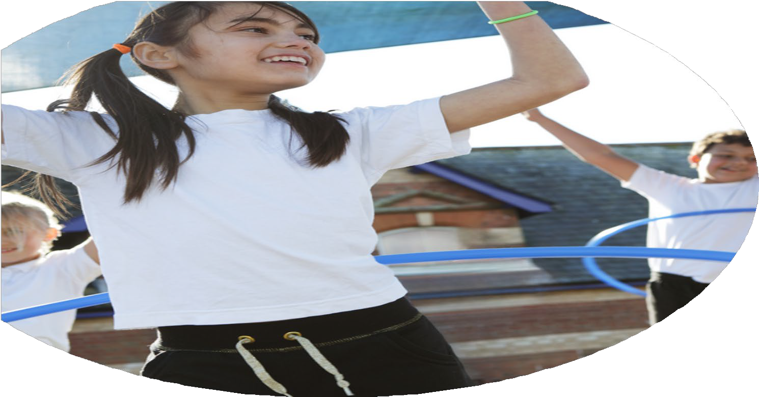
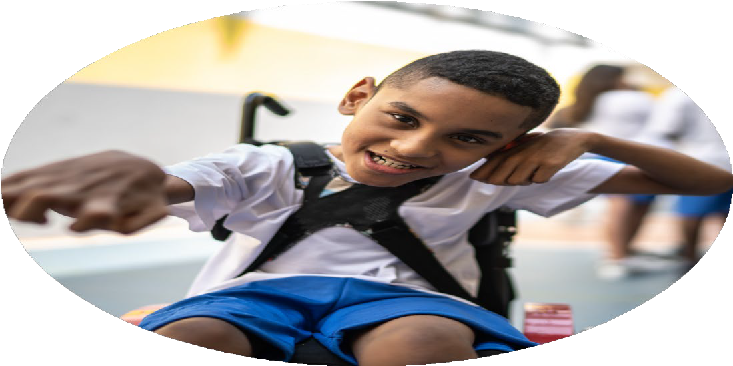




PE Funding

Evaluation Form

Commissioned by

Created by

Images courtesy of Youth Sport Trust

PE Funding Evaluation Form

It is intended that this template should be used as preparation for the completion of the statutory digital reporting tool being introduced this academic year. You can upload data (including swimming) from this template onto this platform once it becomes accessible.
Before you decide how you are going to use the funding for this academic year you should reflect and evaluate the impact of your use of the funding in 2023/24.
All spending of the funding must conform with the terms outlined in the Conditions of Grant document. The template is a working document that you can amend/update during the year.
Based on your evaluation of last year’s funding you should decide what you intend to do this academic year, how you will do it, and what impact you expect it to have.

It is important that the funding is used effectively and based on your school’s needs.
You must use the funding to make additional and sustainable improvements to the PE and sport in your school. You must develop and add to the PESSPA activities that your school already offers.

Summative digital reporting from June 2025 will continue to include swimming and water safety information therefore funding can be used to provide top-up lessons where necessary to ensure pupils meet national curriculum swimming requirements.

We recommend that you start by reflecting on the impact of current provision and reviewing your previous spend

What went well? | How do you know? | What didn’t go well? | How do you know?
See 2023 – 24 plan on school website.

What are your plans for 2024/25? | How are you going to action and achieve these plans?
Intent | Implementation
- Provide engaging opportunities for children to engage in physical activities so they can apply fundamental movements during social times  - Improve the quality of PE teaching through CPD  - Broaden the range of sports and physical activities offered  - Promote healthy, active lifestyles, improve pupil wellbeing and physical literacy  - Deliver catch up swimming to Year 6 to ensure children meet the national standards  - Upskill PE Leader subject knowledge to lead subject effectively and keep up to-date with policies and provision  - Replace and / or update equipment to ensure that children have adequate access to resources they need and teachers have what they need to deliver the curriculum effectively  - Replace the gymnastic mats | - Offer pupils the chance to represent the school in a variety of age-appropriate sports events  - Create enriching experiences through year group-specific sporting excursions and events  - Attend the PE conference

What impact/intended impact/sustainability are you  expecting? | How will you know? What evidence do you have or  expect to have?
- Staff CPD has built long-term capacity to deliver high-quality PE but increasing confidence, knowledge and skill  - Equipment purchased will support future cohorts and curriculum  - Higher levels of participation and engagement in physical activity through school routines (daily mile/ frequent movement breaks) events and festivals  - PE curriculum reviewed and updated to ensure progression and inclusivity  - PE leader confidence increased  - Broader experiences and confidence when participating in new activities. | - Staff and pupil voice  - Attendance records from PE conferences with Solihull Sports Partnership  - Children are engaged in their PE sessions  - Percentage of children meeting the swimming national standard for KS2  - Children will have the confidence to participate and try new physical development skills taught during the PE lesson

What impact/sustainability have you seen? | What evidence do you have?
- Staff have increased confidence, knowledge and skill to deliver high quality PE  - Equipment purchased will support future cohorts  - High levels of participation in physical activity through events and festivals  - PE curriculum reviewed and updated to ensure progression and inclusivity  - A range of sports and activities have been delivered throughout the year  - The confidence of the PE subject leader has improved | - Staff are confident in PE delivery  - The profile of PE and sport is high across the school  - The PE subject leader has 100% at all the PE conference days throughout the year

