Key Instant Recall Facts
Year 6: Spring 2
WALT: find basic fractions and percentages of amounts
This KIRF will be tested at the start and end of the term. In school, your child will receive one, fifteen-minute, timetabled slot a week to practise this skill. By the end of this half term, children in Year 5 should know the following facts and be able to recall them instantly:

What does this look like?
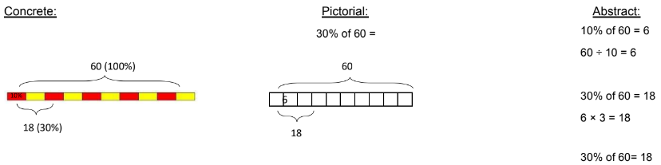

Can you find benchmark percentages confidently?
The benchmark percentages are 1%, 10% and 50%. Explain to your parent how you find them. (To find .....% you divide by ........)

Remember: Fractions, decimals, and percentages mean the same thing! You can convert to the one you prefer if you want! E.g. finding 10% is the same as finding $\frac{1}{10}$ of an amount!
Key Vocabulary:
Equivalent- Have the same value.
Per cent- Parts per 100. It shows the ratio ‘out
of 100’.

Key Questions:
What is 30% of 20?
How does finding 10% help me find 5% of a number?
How do you find 80% of 50?

Handy Hint: In maths, x and of mean the same thing! e.g.
10% of 360 = 36
10 % x 360 = 36
$\frac{1}{10}$ of 360 = 36
  - x 360 = 36
Play Games!
✓ Create a board game or a treasure hunt related to multiplying/dividing by 10, 100 and 1000.
✓ Make some flashcards and ask a family member to test you- how quickly can you multiply/divide by 10, 100 or 1000.
✓ Create a poster for multiplying/dividing by 10, 100 and 1000.
Top Tips:
The secret to success? Practise little and often! Can you learn these on your way to school? On a car journey? Or even at the breakfast table? You don’t need to learn them all at once: start with those you are more confident with before tackling the rest. Why not practise whilst keeping active? You could throw and catch or kick a ball whilst learning them!

Useful Websites (games and information):
https://mathsframe.co.uk/en/resources/resource/264/Crystal-crash-fractions-numbers
https://www.topmarks.co.uk/Flash.aspx?f=bingofractionsofamountsv3

