Key Instant Recall Facts
Year 5: Spring 2
WALT: multiply and divide by 10, 100 and 1000.
This KIRF will be tested at the start and end of the term. In school, your child will receive one, fifteen-minute, timetabled slot a week to practise this skill. By the end of this half term, children in Year 5 should know the following facts and be able to recall them instantly:

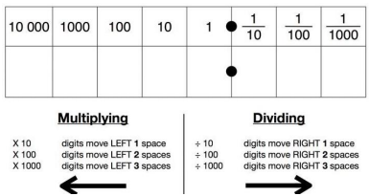
When we multiply by 10, 100 and 1000 we shift the digits to the left. One place left for 10, two places left for 100 and three places left for 1000. When we divide by 10, 100 and 1000, we do the opposite and shift the digits to the right instead. The order of the digits will always stay the same, their place value will change.
Key Vocabulary: whole number, decimal number, place value, multiply, divide, digit.

7 multiplied by 100 is equal to 700
120 shared by 10 is equal to 1.2
132 divided by 12 equals 11
0.6 is zero ones and six tenths
One tenth and four hundredths is 0.16

Key Questions
What number is 10 times bigger than 0.1?
What number is 100 times smaller than 12?
What is 152 ÷ 1000?
45 = ? x 10

Handy Hints:
- Underline the zeros in the power of 10! E.g. 10 = 1 zero, 1 leap! 1000 = 3 zeros, 3 leaps!
- Double check your sign! E.g. x the answer will be larger, ÷ the answer will be smaller!
Top Tips:
The secret to success? Practise little and often! Can you learn these on your way to school? On a car journey? Or even at the breakfast table? You don’t need to learn them all at once: start with those you are more confident with before tackling the rest. Why not practise whilst keeping active? You could throw and catch or kick a ball whilst learning them!

Play Games!
✓ Create a board game or a treasure hunt related to multiplying/dividing by 10, 100 and 1000.
✓ Make some flashcards and ask a family member to test you- how quickly can you multiply/divide by 10, 100 or 1000.
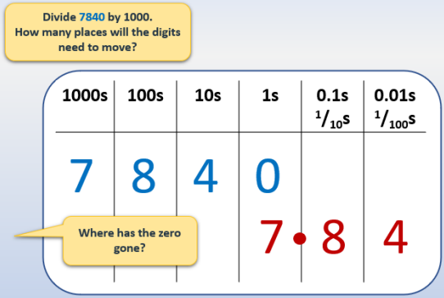
✓ Create a poster for multiplying/dividing by 10, 100 and 1000.
Useful Websites (games and information):
https://www.bbc.co.uk/bitesize/topics/zc3d7ty/articles/zmk72v4
https://www.youtube.com/watch?v=Y45H5aCuymg
https://www.topmarks.co.uk/Flash.aspx?f=bingotimesordivide
https://kids.classroomsecrets.co.uk/resource/year-5-divide-by-10-100-and-1000-game/
https://wordwall.net/en-gb/community/multiplication-by-10-100-1000

