Key Instant Recall Facts
Year 4: Spring 2
WALT: tell the time to 5 minute intervals
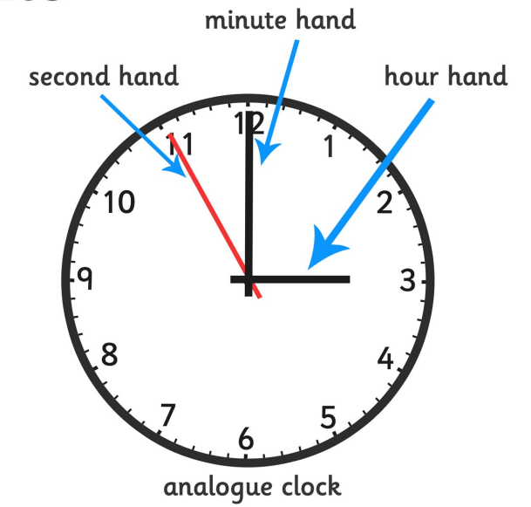
This KIRF will be tested at the start and end of the term. In school, your child will receive one, fifteen-minute, timetabled slot a week to practise this skill. By the end of this half term, children in Year 4 should know the following facts (Revisiting KS1 learning) and be able to recall them instantly:
Key Vocabulary:
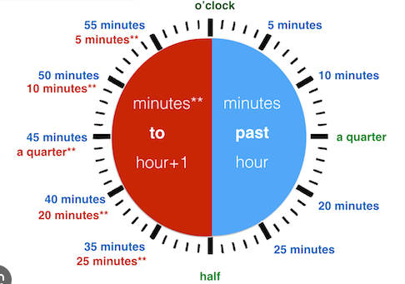

Key questions:
What time is it now? How do you know? i.e. what hands are pointing where…
In 15 minutes we will be going to Tesco. What will the clock look like?
The digital clock/ iPhone reads XX:XX, what would this look like on an analogue clock?

Top Tips:
The secret to success? Practise little and often! You don’t need the entire clock at once. If you find your child finds time tricky, start by pointing out o’clock and talking about the different hands and what they mean. When they ask what time it is, encourage them to work out with you rather than look at a digital clock. If tea is in 15 minutes, where will the clock hands be? Time is best learnt practically and in context.

Useful Video Links:
https://www.youtube.com/watch?v=V32tRiEQ2AA&list=PLWIJ2KbiNEypQx6oZDAuyI55g_ShOQRNx – Maths4Kids is a great channel and has lots of useful videos to help with a variety of maths areas. We use this video to support the learning of time. In school we will use this method. (The first video in the link goes through o’clock and half past, the second quarter to and quarter past, the third to 5-minute intervals, and finally the fourth to one minute intervals. Please start at the point you need to).

Get Creative!
✓ Create a rough timetable for an average day so that children are aware of what roughly happens around o’clock and half past the hour, e.g. 7.30 – we brush our teeth.
✓ Design a matching game – this is a good one to take inspo from or download https://www.twinkl.co.uk/resource/telling-the-time-ice-cream-cone-half-past-and-oclock-matching-worksheets-activity-activity-t-n-10362
✓ Create a paper clock using card and split pins – sometimes the simplest of activities is the best.

