Key Instant Recall Facts
Year 1: Spring 2
WALT: know number bonds to 20 (subtraction)
This KIRF will be tested at the start and end of the term. In school, your child will receive one, fifteen-minute, timetabled slot a week to practise this skill. Number bonds show us how numbers join together. They are very important for addition and subtraction. This half term, the children will be learning number bonds that make 20 again, but in the form of subtraction. By the end of this half term, children in Year 1 should know the following facts and be able to recall them instantly:

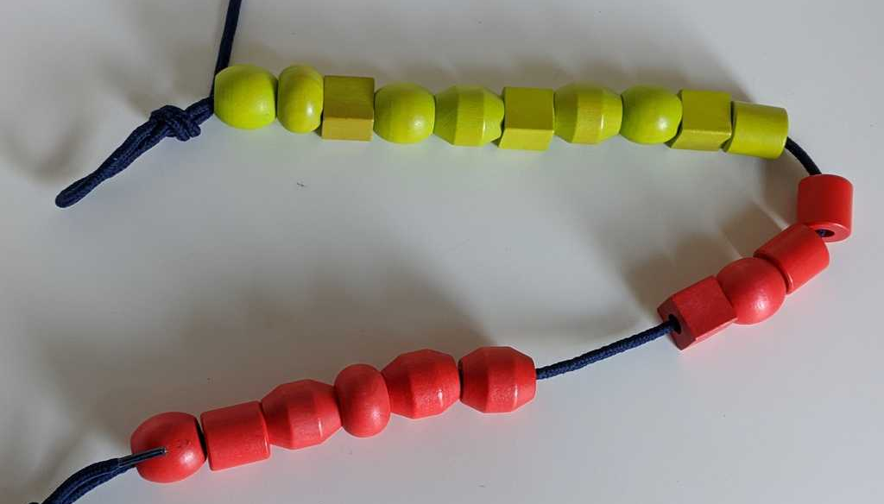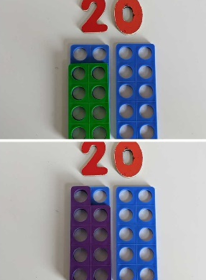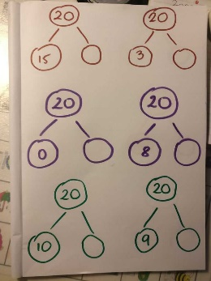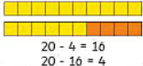

Top Tips:
The secret to success? Practise little and often! Can you learn these on your way to school? On a car journey? Or even at the breakfast table? You don’t need to learn them all at once: start with those you are more confident with before tackling the rest. Why not practise whilst keeping active? You could throw and catch or kick a ball whilst learning them!

Things to Try!
✓ Create pictures of ladybirds. Put spots on 2 sides so that they add up to 20.
✓ Play bingo. Say a statement e.g. 20 - _ = 12. If they have the missing number, they can cross it off their card.
✓ Play snap with a deck of cards from 0 – 20. Say snap if the numbers are a pair that make 20.
✓ Use objects e.g. cars. Start with 20 cars. How many have I taken away? How many do I have left? How many do I need to put back to have 20 again?
Practice chanting the number bonds.
Try creating paper chains - Use two different colours to make paper chains to show each number bond, for example 14 + 6 could be shown as 14 green links and 6 blue links.
Key Vocabulary:
Subtract, less, minus, make less, left, total, equal to, count back.

Key Questions:
How many are left out of 20?

20 – 15 = ___
20 -- ___ = 7
10 = 20 -- ___
20 – 1 = ___

How can you use your number bonds to
10 to help you?

Say it, make it, write it - For each number bond, say it our loud, make it using everyday objects and then write it as a sum.
Put 20 pegs on to a coat hanger, split them in different ways and count how many pegs are on each side. E.g. 14 pegs + 6 pegs = 20 pegs (14+6=20).

Useful Websites (games and information):
https://whiterosemaths.com/resources/1-minute-maths
https://www.topmarks.co.uk/maths-games/hit-the-button
https://www.ictgames.com/funkyMummy/index.html

