Key Instant Recall Facts
EYFS: Spring 2
WALT: understand fewer, more and equal to
By the end of this half term, children in EYFS should know the following facts and be able to recall them confidently:

Number to 10 in order:
Key Vocabulary:
more than, less than, greater, smaller, fewer, larger, equal, the same as.

Key Questions:
Which pile of cars is greater?
Which set of crayons is fewer?
How can we make these plates of grapes the same?
0, 1, 2, 3, 4, 5,
6, 7, 8 , 9, 10

Top Tips:
The secret to success? Practise little and often! Can you learn these on your way to school? On a car journey? Or even at the breakfast table? You don’t need to learn them all at once: start with those you are more confident with before tackling the rest. Why not practise whilst keeping active? You could throw and catch or kick a ball whilst learning them!

Things to Try!
✓ rolling a dice – can you think of a number less or more than the value you have rolled?
✓ sorting dominos – can you make a pattern then find more than/ less than a number each time
Check out this episode of Number Blocks: https://www.bbc.co.uk/iplayer/episode/b0blsqtz/numberblocks-series-3-blockzilla or this one: https://www.bbc.co.uk/iplayer/episode/b0bmkk2p/numberblocks-series-3-peekaboo

Useful Websites (games and information) around counting to 10:
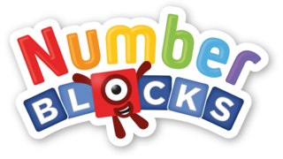
https://www.topmarks.co.uk/learning-to-count/teddy-numbers
https://www.topmarks.co.uk/learning-to-count/underwater-counting
https://www.topmarks.co.uk/learning-to-count/gingerbread-man-game
https://www.topmarks.co.uk/learning-to-count/ladybird-spots

Challenge: Begin to form the shapes of the numbers correctly

