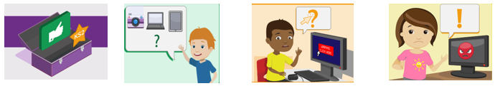
KS2 Acceptable use agreement
- I will respect computing equipment and will immediately notify an adult if I notice something isn’t working correctly or is damaged.
- I will use all communication tools such as email and blogs carefully. I will notify an adult immediately if I notice that someone who isn’t approved by the teacher is messaging.
- Before I share, post or reply to anything online, I will T.H.I.N.K.
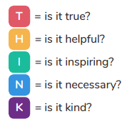
- I understand that if I behave negatively whilst using technology towards other members of the school, my parents/carers will be informed, and appropriate actions taken.
- I will only access computing equipment when a trusted adult has given me permission and is present. I will not deliberately look for, save or send anything that could make others upset.
- I will immediately inform an adult if I see something that worries me, or I know is inappropriate.
- I will keep my username and password secure; this includes not sharing it with others.
- I understand what personal information is and will never share my own or others’ personal information such as phone numbers, home addresses and names. I will always use my own username and password to access the school network and subscription services such as Purple Mash.
- In order to help keep me and others safe, I know that the school checks my files and the online sites I visit. They will contact my parents/carers if an adult at school is concerned about me.

Date:_____________________________

