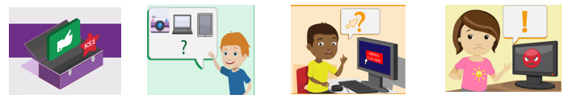
KS1 Acceptable use agreement
- I always ask a teacher or suitable adult if I want to use the computers, tablets or cameras.
- I only open activities that an adult has told or allowed me to use.
- I know that I must tell an adult if I see something on a screen that upsets me, or I am unsure of.
- I keep my passwords safe and will never use someone else’s.
- I know personal information such as my address and birthday should never be shared online.
- I know I must never speak with strangers online.
- I am always polite when I post to our blogs, use our email and other communication tools.

I understand what this means and I understand the dangers if I do not follow it:

Date:

