Looking After Ourselves and Others
Where to look for more support and information.
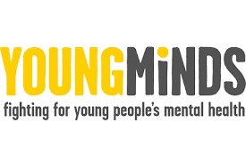
Young Minds
Mental health charity supporting parents and children. Lots of information and some activity ideas to promote self-confidence and self-care. (Free, age range Primary-Young Adult)
https://youngminds.org.uk/
https://youngminds.org.uk/find-help/for-parents/

https://www.kooth.com/
Kooth is a web based confidential support service available to young people. Kooth provides a safe and secure means of accessing mental health and wellbeing support designed specifically for young people. (Free, ages 11+ to young adult). Please see my letter from earlier this term to Y5 and Y6 for more information.

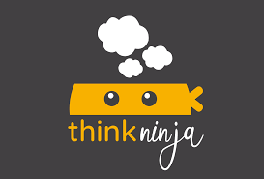
Think Ninja is an NHS developed app for ages 10+.
Specific support for navigating the pandemic has been added. Available on iOS and Android.
See my letter for more info.
https://www.healios.org.uk/services/thinkninja1

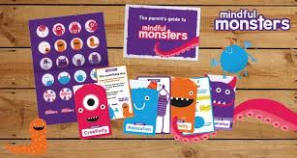
Focussed around 4 key areas; positivity, relaxation, concentration and creativity. We'll send you monthly deliveries of unique activity cards that are designed to make practicing mindfulness easy and fun. (Subscription, age range Primary upwards) https://mindfulmonsters.co.uk/

https://www.calm.com/
Mindfulness, meditation, yoga, sleep stories and music to support relaxation, focus and sleep. App and web access. (Subscription: content ages 5+ to adults)

https://www.headspace.com/
Mindfulness and meditation app (Subscription, content Primary age to adults)

The Solihull Local Offer has more information for supporting children with Special Educational Needs. The following organisations also offer resources and information. Please contact your linked professional or Mrs Gray for more information. https://socialsolihull.org.uk/localoffer/
